1
Chera, chola andpadnya ye do bhago me ate hai ke pracheen kaal me aur dusra early medivial time per jinhe hum sahe chola bheb bottle hai
Pracheen chera , pracheen chola and pracheen pandya
Sangam kaal me mudkhay roop se literature se ya fir words se questin he puche jate hai
Nadu kya hia urr kya hai etc

Administration vocabulary and literature sangam age se yahe se padhne per pcomanlet ho jayega 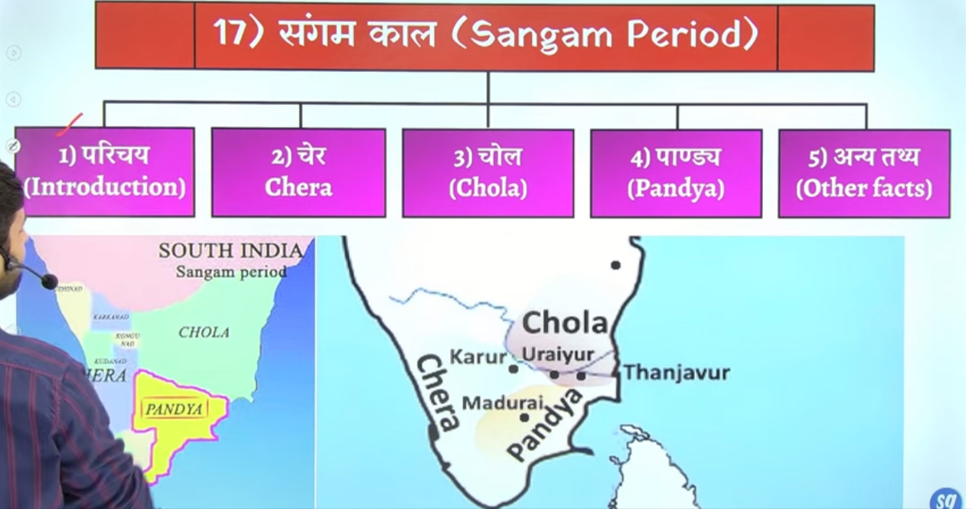

Chera ka reference hume sangam age me sabse Jayda baar hua ahi

Sangaam kaal ka matlba kya hai
Aise amana gayay prachen kaal me south me teen prachen rajvansh the ke tha chola dursra chera and thers pandya
Chera me do main city the uraiyur, Thanjavur,
Chera = karur
Pandya = Madurai

Ye teen dynasty hume southern extension me dkehtne ko mitle hai jisne main shahr map me dyai ahi

Aiasa kaha jatya hia ke pandya rajao ne lagabhag 9000 salo tak sangam sabha ka ayojan kyia is sangam sabha me kavi aur vidyawan hote the poet and scholor hote the
Jiase koi bhe koi rahcna likh kar layay to pahle wo Rahna is mandal ke samene pesh ke jate the aur agar use approve kar dyia jata to usko sangam saheyta ka hissa man lyia jata tha

Sangam kaal ka matlab yahe hai ke 9000 salo tak pandya rajao ke sanrakhsna me 3 baar sangam sabhao ka ayojan hua hai aur in sangam sabhao me jo sahetyia literature likha gayay usko he hum sangam litreutr kahte hia

Intresting hia ke sangam literature ka subject dharmic nahi hai halaki usme dharm ke charch hai but usme love and war ke bare me Jayda mention kyia gay hia religion ke bare me bahut kam charcha keg ae hai ise dharmanirapekshya sahetya bhe kaha gaya isko secular literature bhe kahah gayay

To jb aap kahte ko sangam kaal to means app charah kar rahe ho prachene chola prachen chera and prachen padnya ke
Pandya – tamilanidu
Chola tamilanid +andrpadesh ka area
Chera =kerla wale earea me
Inhe rajyao ko prachen sangam rajya state bhe kaha gaya tha
Sangam means sabha iase sabhah jaah alag alag scholor aa kar mile
Alag ala gvihaor ke scholor akar milte hai alag alag tarha ke log aa kar milte hai

Pandya rajo ke sankrakhna me teen sangam sabhao ka ayojan kyia gay aur ye sabha 9000 hara sala tk chalte rhea aur labgha 200 king ne inko patrnoze kyai tha pandya 200 rajao ne patrnoze kyai uske baad jo literature bana use hamen sangam literature khaha

Q yah keis tarah ka sahahsn chalta tha

Sangam word ko tamil me machungam kaha gaya ya fir teen sangam sabho ko machungam kaha gayay hai
Sangam sabhah= tamil me machungam

Sangam meas parsehad ya gosthi, assembly symposium

Shavi santo ko south me nainar kaha jata tha
Viashva santo ko south me kya kahah jata tha ? aur us vaishano santo me ek matra mahila kaun the ?
Nainar santo ke sankhya ky ahte ?

Is litreatue ka compilation hua hai 300BCE 300Ce ke beech me

Note sangam litreute ka main subject religion nahi tha love and war and socity ye main subject the sangam literature ke 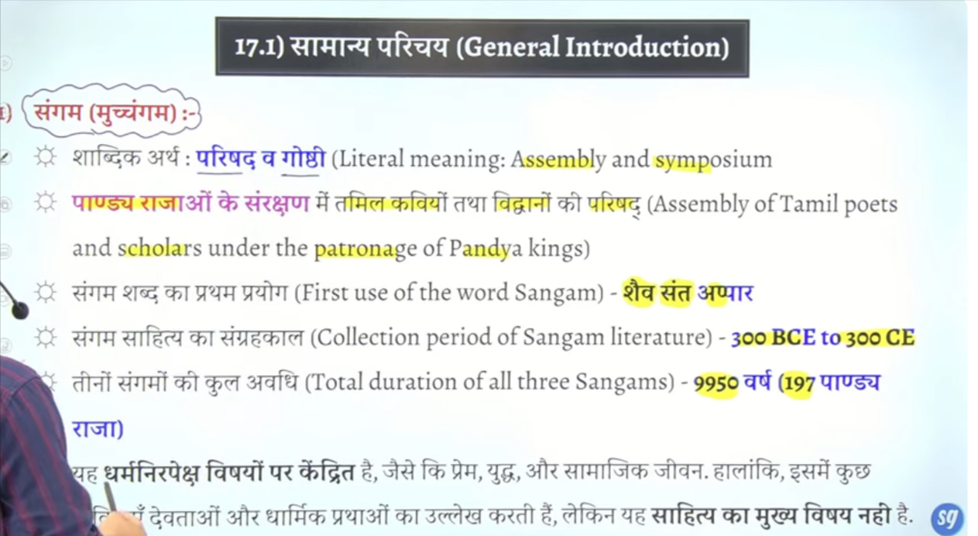

Religion ke charahc bahut kam keg ae hai sangam litreutre me most important
That is something that u need to remember

Teen sanga sabha ka ayojan hua tha

Tolkapiyar scolor the tolkamiyam is tamil grammar book
Third sangam me bahtu sare book lekeh gae the multiple literature dekne ko milte thia
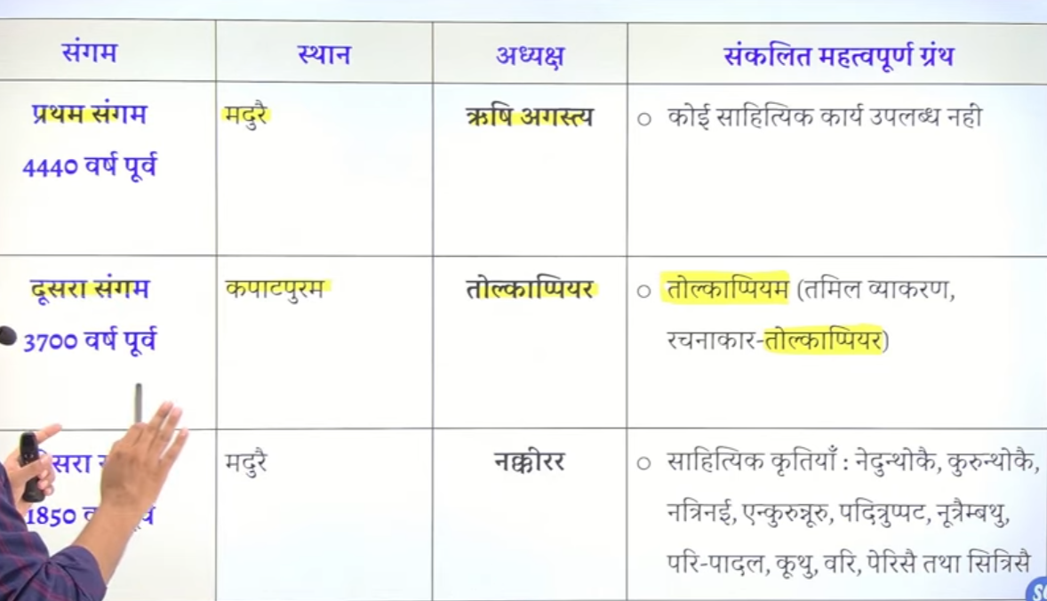

Vindhya mountain range hia wo north and south ko divide kartehai to
Aruya Sanskrit ke jbshurat hue to arya Sanskrit mukhya roop se north idnia me faile
Arya culture ko south india le gae the rishi Agastya is kaam me rishi Agastya aur srisshi kandyea ka bahtu bad yogdaan hai

Rishi agasty ke 12 seshya the jime se ek the tollkapyiar jonhe tolkamiyam book likhe jo tamil grammar ke book hai

Q south india me arya sansakrit le jane ka sherya kise dyia jata hai
?
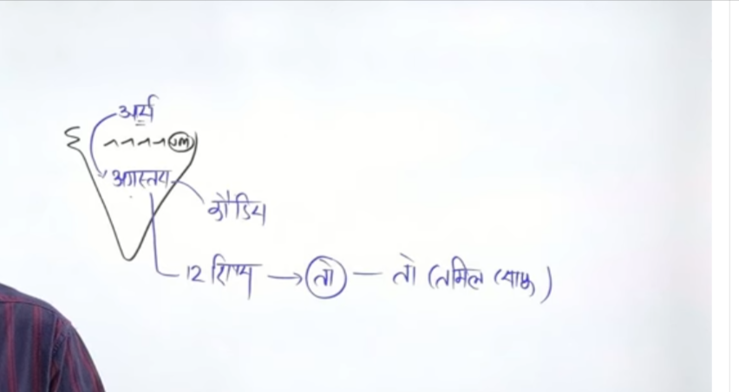 roshi Agastya and kondeya

Q sangam kaal ka kyameansing hai

Chola ke teen pramukh nagar the
Puhar jise kaveri patnam bhe kahte hai , tanjaur, urayur

Chola sabse adhk powerful the inanient time
Chera= kerala
Main city the karuru

Extreme tamil ka jo area hai waha per pandya dekhne ko milte hai
Jinka mukhya kendra jo rahah hai wo madurae rahah hai

197 padnya rajao ne lagbhg 10000 hazar salo tak bahut sare tamil kavi aur aur bahut sare tamil scholor vidhwano ko snarakhsan dyia tha aur unke jo sabha bane usko he sangam kahah gay assembly of thsose scholor is called sangam
Is sabha me jo literature ke rachna hue the usko he hamen sangam litreatur ekha tha 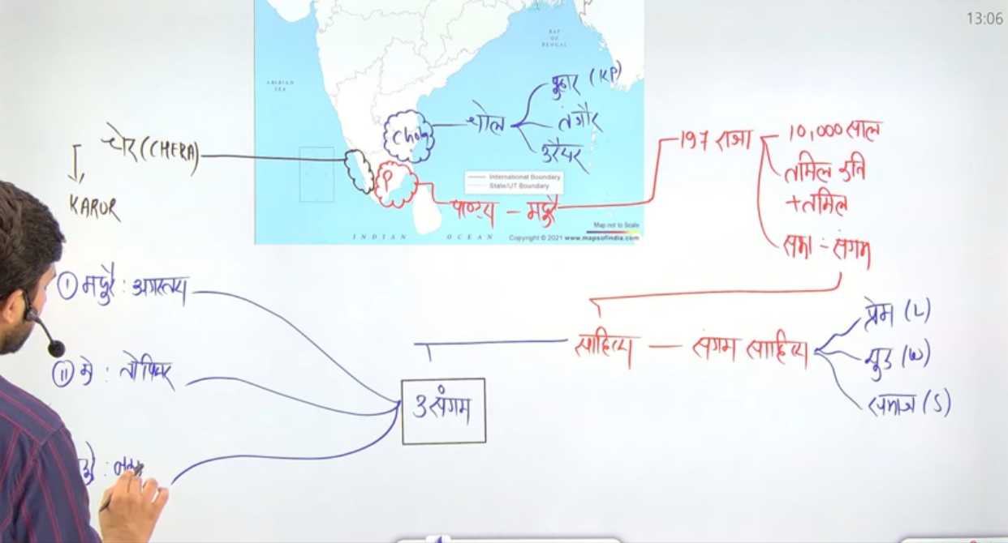

Dusre sangam ka sirf ek litreatur availbe hai

And third sagnam ke multiepple literature mile hai

Source
Sagnam sathyta and sangam litreute ki jankari hume kahah kahahse mitle hai

Rome ka sarvadhik vyapapr Dakshin bharat se hota tha panducherry ke paaas ek arekmedu naam ke jagha hai wahah se hume rom eke bastyia and aur unke coins mile ai
Urayur us tiem per suti vastra ka ek bahut bada center tha aise he tanjaur and maduryae bhe vaypaar ke bahut bade kendra hua karte the
Rome ke sath bahut lamba vyaptar hota tha
To megnasthenez, Strabo pliney ne bhe south india ke difernt rajao ke bare me likha hai 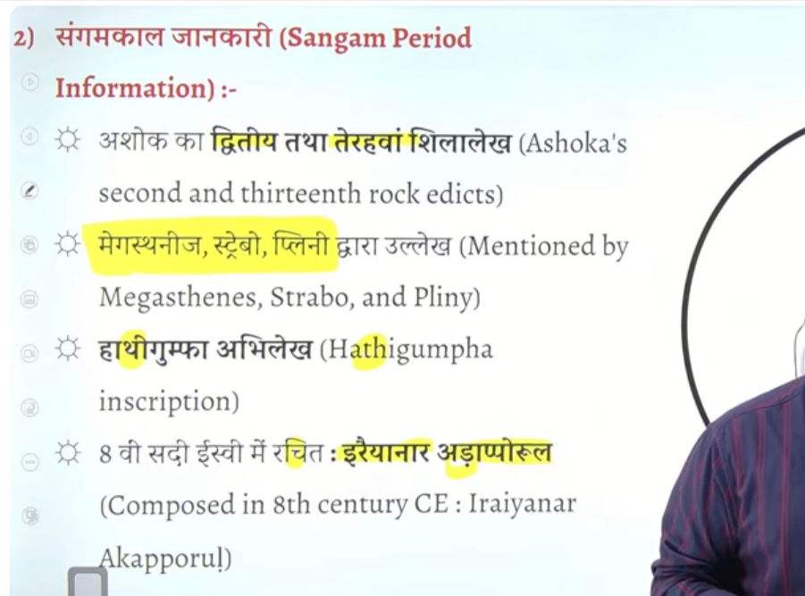

Teeno sangam sabho ya fir sangam sabha ko muchnaganm kaha gaya tha

Sangam sahtya ke subject ko hum do bhago me baat sakte hai
Ek hai akam and dusra hai puram
Akam mme love ke topic hai and puram me war ke topic hai

Ise tarha se sangam litreture ko three part me divide kyia gyaa hai
Adhinkas litretue padhya ke roop me milta hai means kavitao ke ropp me poetry fom me milta hai
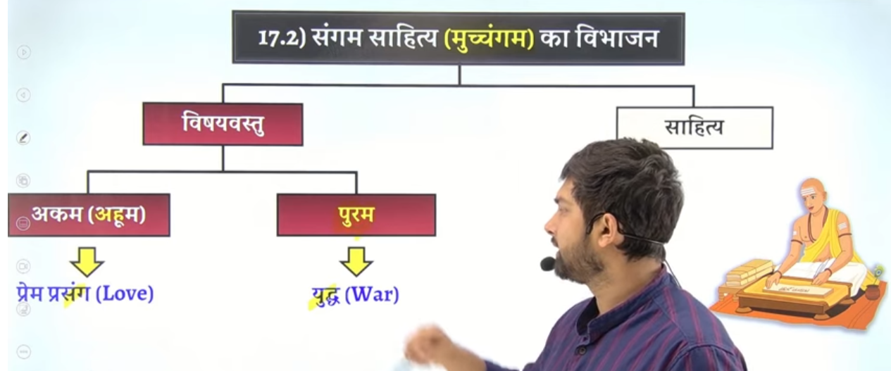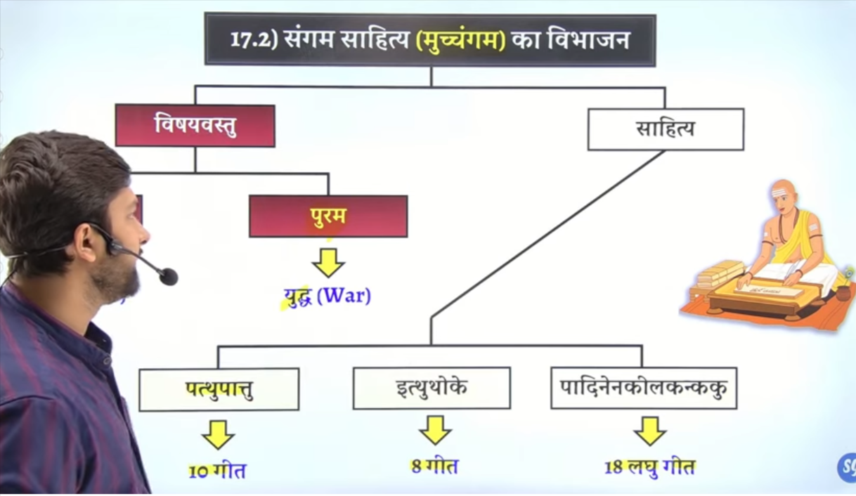

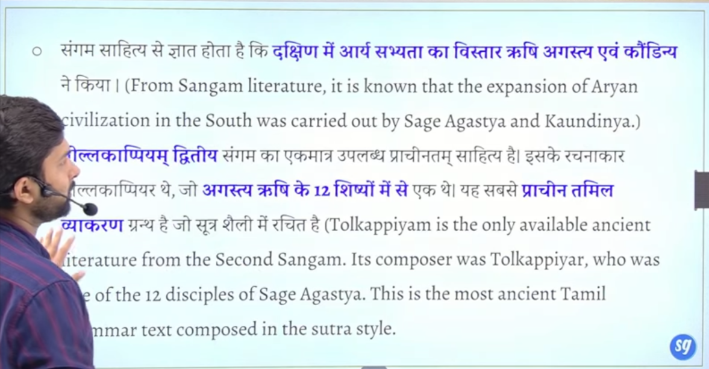

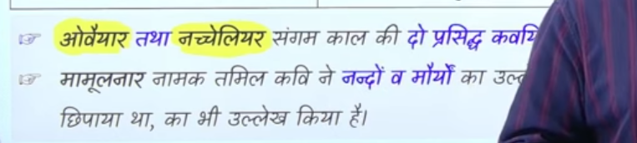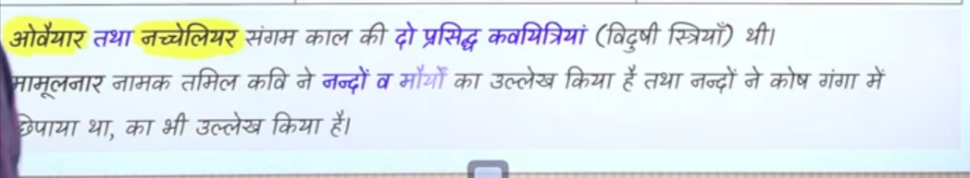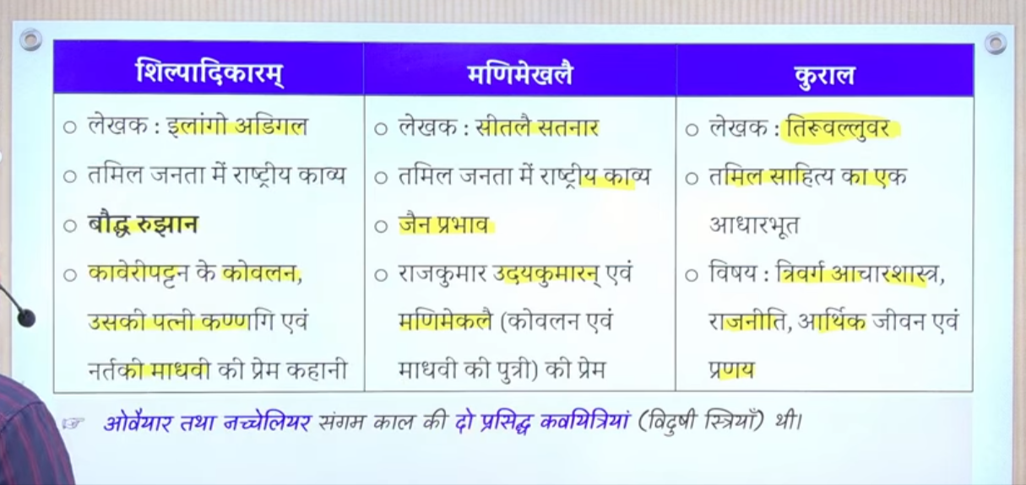

Major tamil literature
Kural jo ke maahan granth hai tamil ka jisee Tiruvallur ne likha
Ahnanoor jise rudrashamrna ne likha
Margarurpadya nakreer ne likha tha
Eramavatram ramayna ka tamil sanskrand hai jise kamban likha hia

These are granth of tamil lteratue r
There are five epic in tamil

Sheelpaadikarma- Elango adegal ne likha hai isme kovalan kadagee aur Madhvi ke Kahane bate gae hai
Kadagee ko to agee jakar puja bhe jane laga tha

Iska khe extension hai mademakhleey jise setaleeya satnaar ne likha hai isme raja udyakumarna aur kovalan aru Madhvi ke beti mademakhlaee ke Kahane hai

Ye five tamil literature hia

Chera

Chera me sabse important king jo hue hai wo senguttuvan hue hai
Question senguttuvan naam ke rajaj ka sambandh kis rajya se tha to answer is senguttvan

Cheata ke Rajdhani vanchu kiruvar, tondi inke capital the

Kanddgi naamak dharmic sampratdya jo ke juda hua sasillapadikaram ke Kahane se uska uska prachana bhe senguttvan king ked aur me hua tha
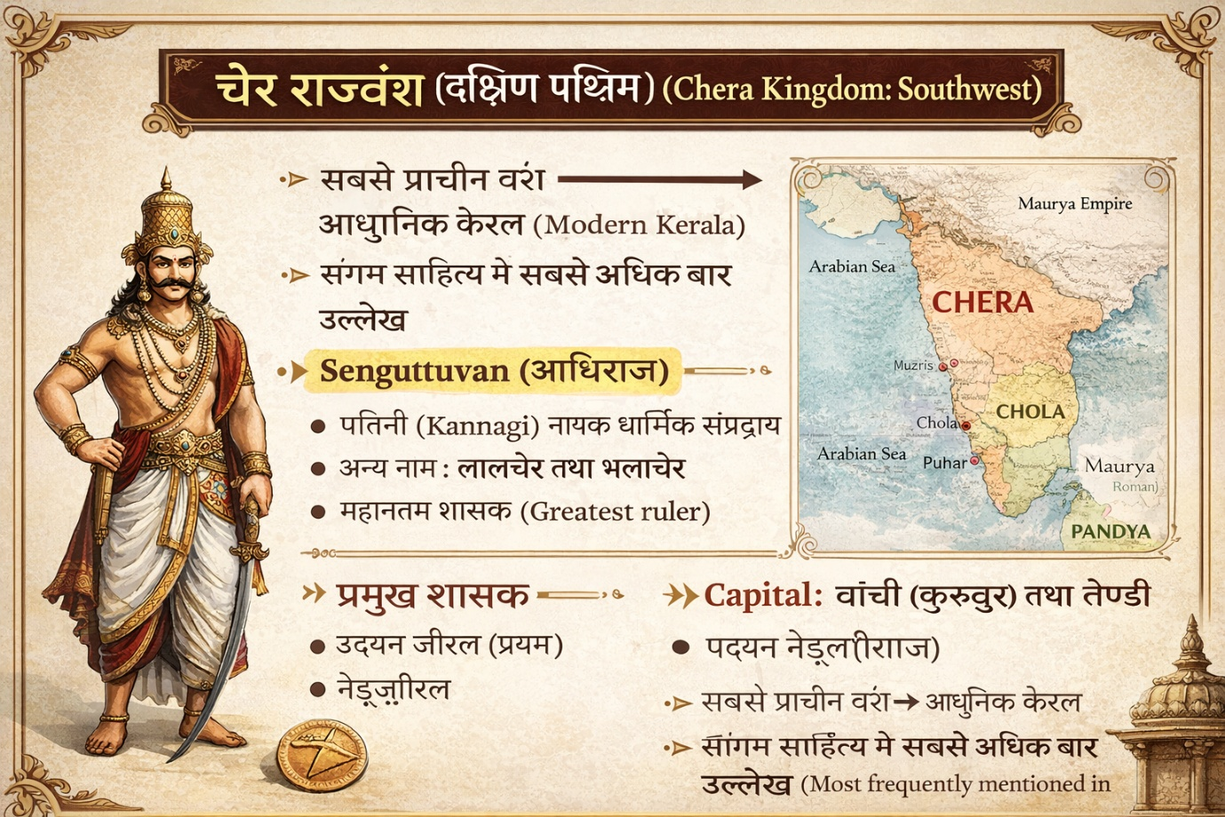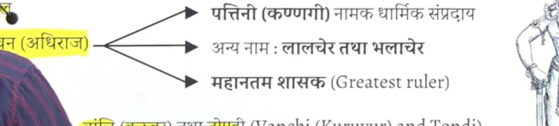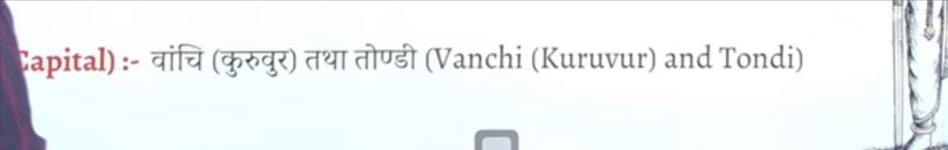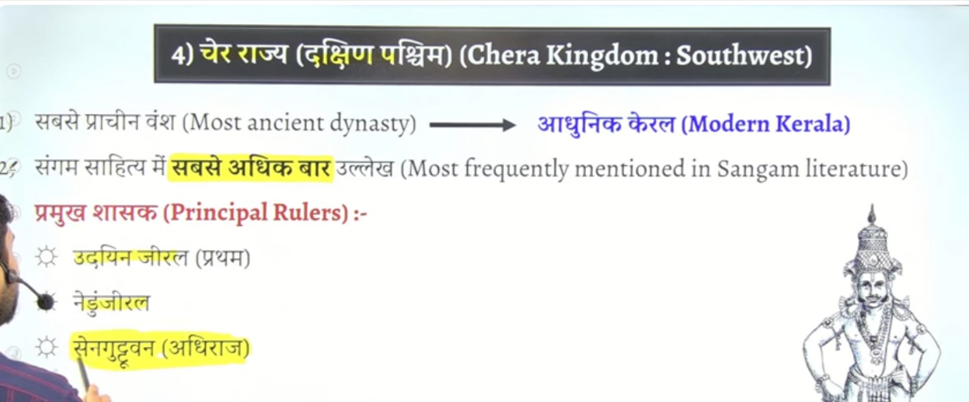

Sabse 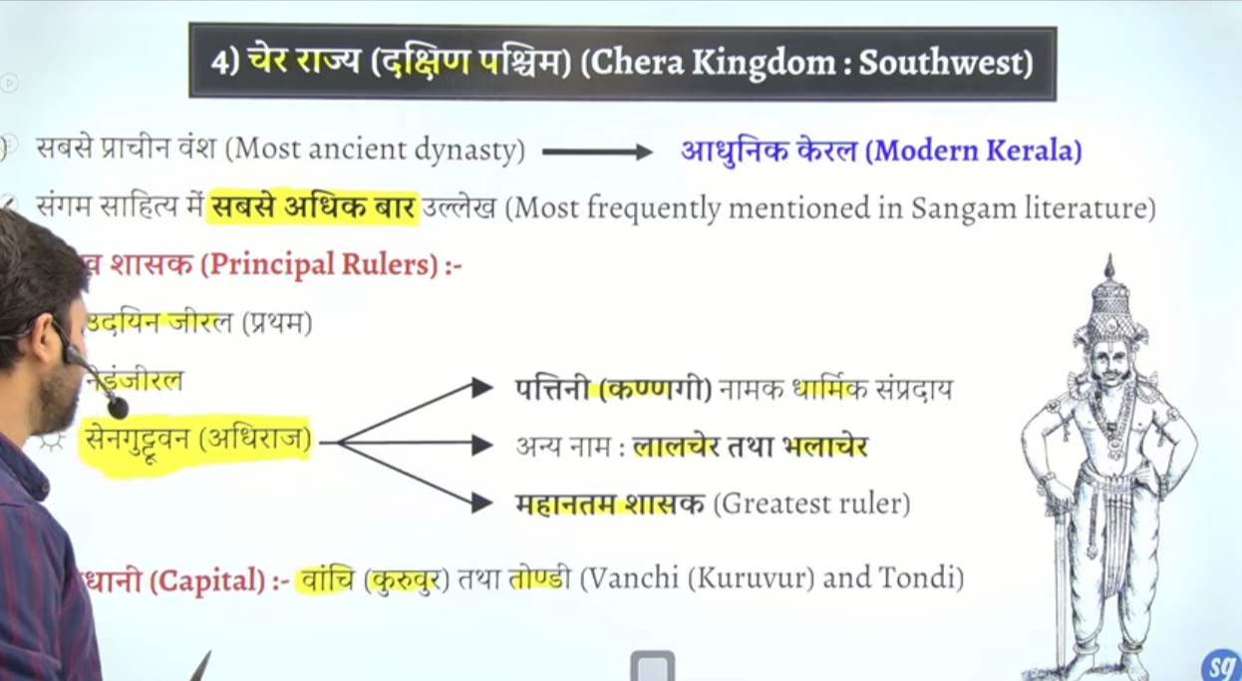

Sbse important king the senguuttvan

Chola king

Chola ka sahasn tamilanadiu me peelar and vellaru nadhyion ke beech me inka shasahhn tha
Ye most powerfull the
Tamilandu and andhrapradesh ka bhe kuch ilaka jisme inka sahsahn tha
Inka symbol tiger tha

Puhar kaveripattanam ek important port bhe tha

Sabse imortnt king kareekal chola hue hai
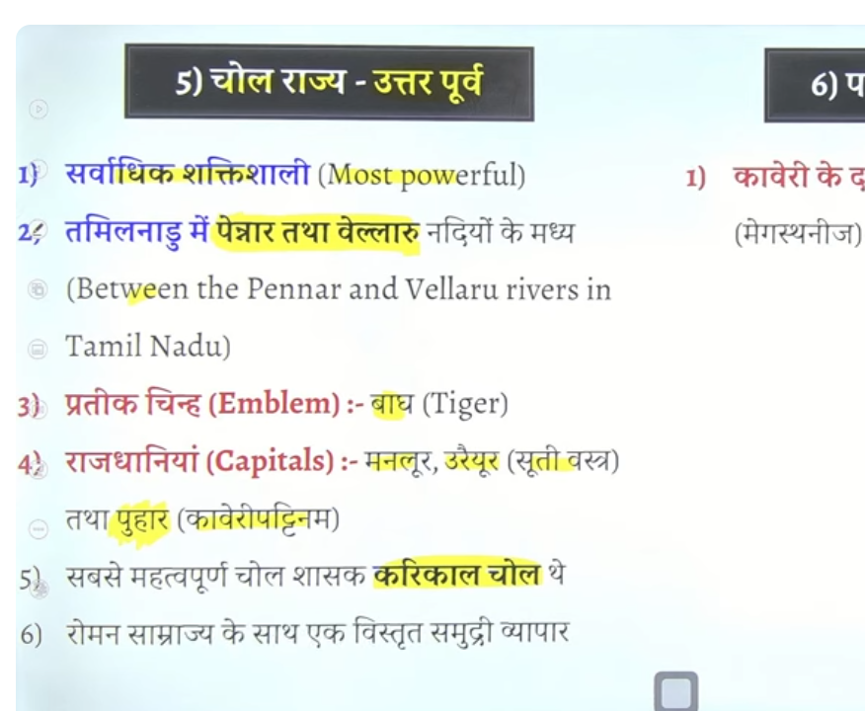

Chera chola and pandya do bar hue ahi ek bar pracehn me and dubaram early medival time me
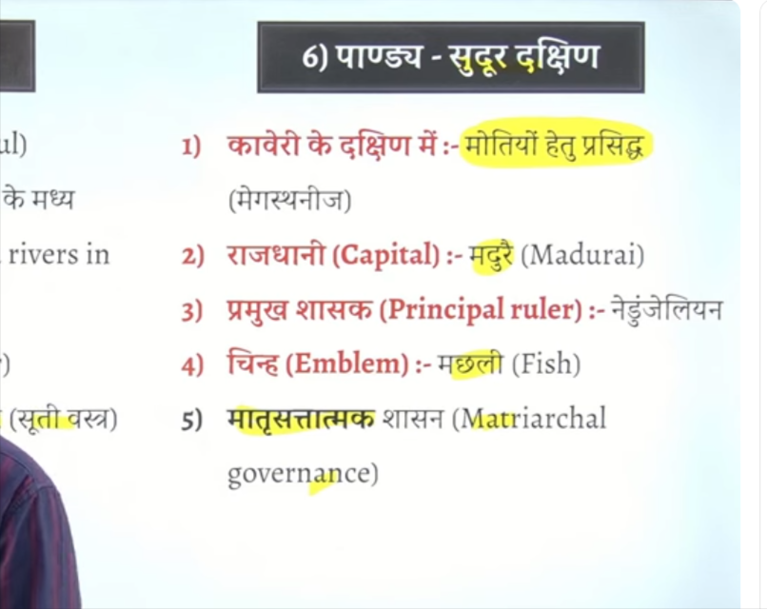

Highest court ko marnalam

North india me varna syst em tha but south me varna system nahi tha yaha samttya do varg the brahaman dusra gair brahaman
Gair brahmano ke sath chua chuttt ka nahi apnaya jata tha aisa koi galat treamten nahi kyia jata tha

Velar ko farmer bote the
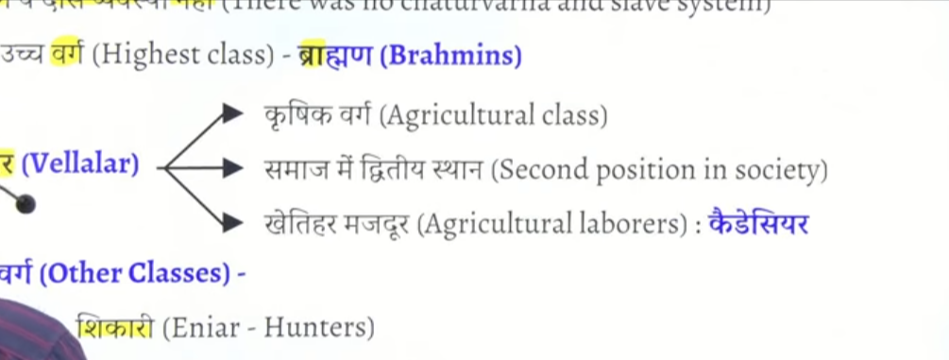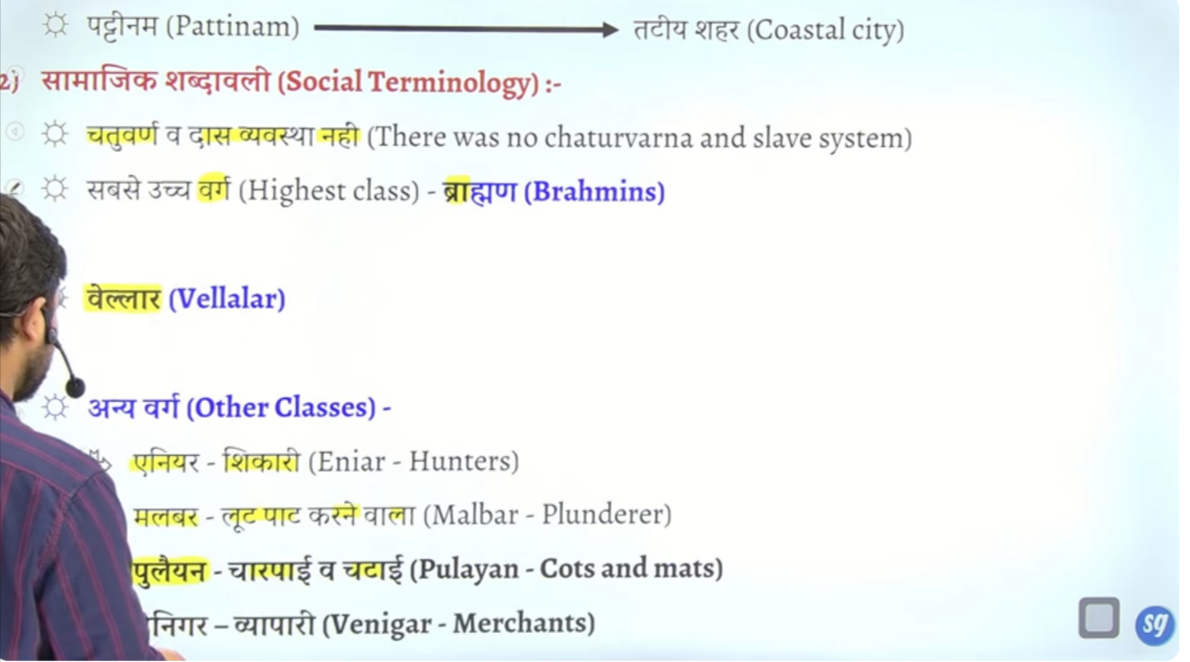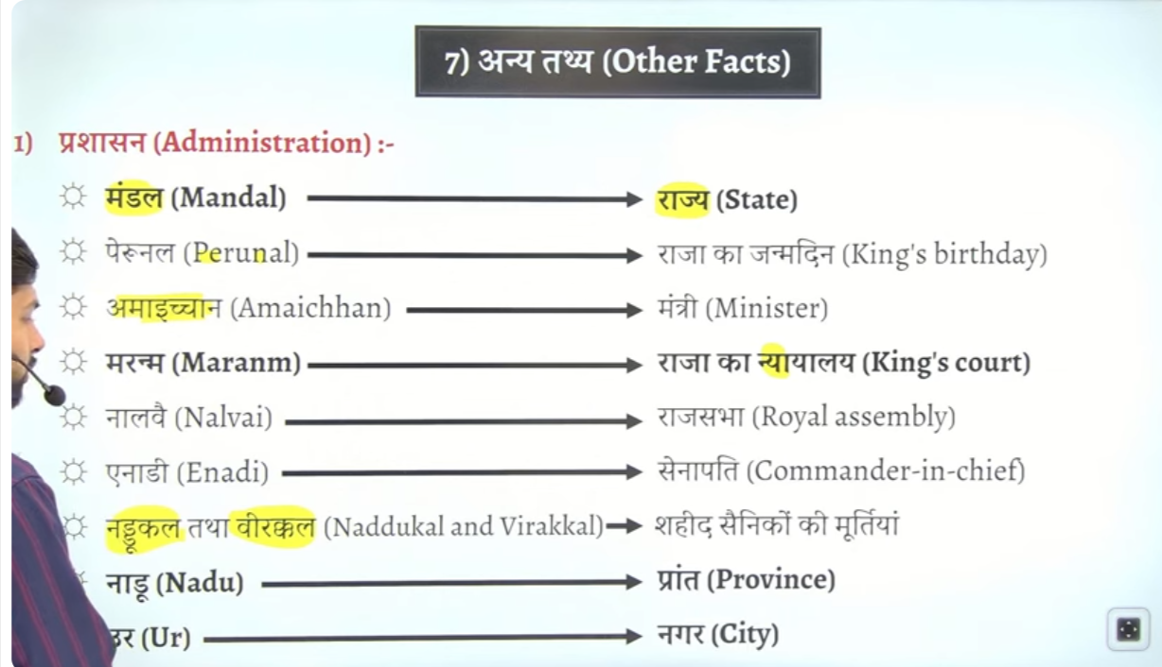

Brahmano ke baad velar ate the farmer log
North ke tarah brahm vivah ke tarha he south me karpu vvivha hota tha

Irai samant ke dwara dyia janaae wala kar Irai
Chekt this

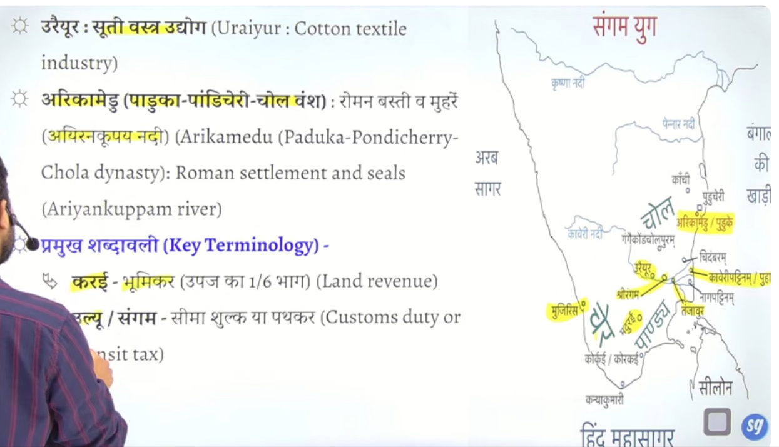

Sangam litreature keimportant devta hai murugan
Murugan ka vahan morre hai but jb inko jhande me dekhaya jata hai to murge se represent kyia jata hai jinhe subhramanayam kenaam se bhe jana jata hai aur inke tulna skand and kartiekya se ke jate hai
Murgan ka symbol murga hai but inka vahahn jo hai wo moore hai
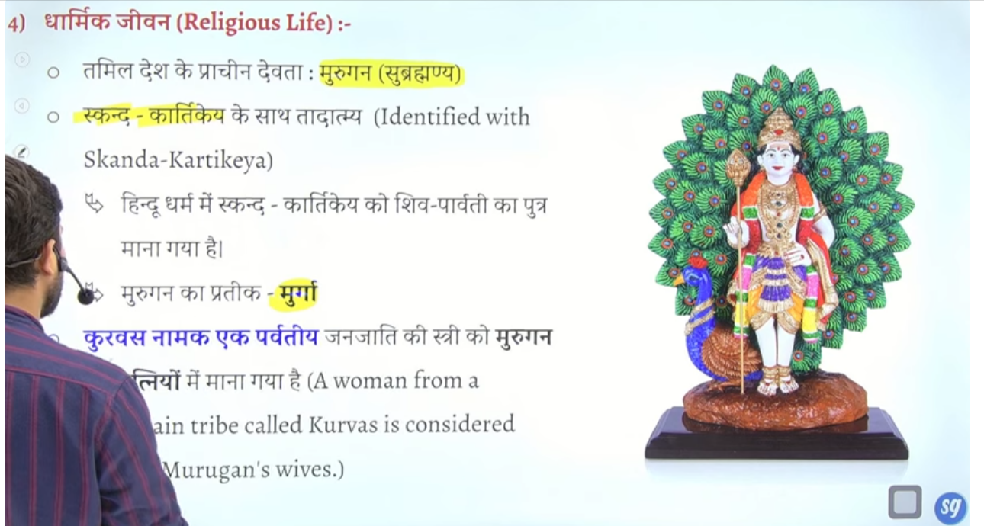

Kurvas naamak ek janjateeya ke women ko Murugan k eke patenyon ke room me mana jat ahi

